MID-TERM PAPER
Major Project (ICT 452)
On
INTELLIGENT INDUSTRIAL SAFETY MONITOR

Submitted in partial fulfilment of the requirement of the degree of

BACHELOR OF TECHNOLOGY
(COMPUTER SCIENCE AND ENGINEERING)


University School of Information, Communication & Technology
GURU GOBIND SINGH INDRAPRASTHA UNIVERSITY, DWARKA , NEW DELHI

Submitted To: Submitted By:
Dr. Sanjay Kumar Malik Name: Harsh Kumar
(Professor at USIC&T, GGSIPU) Enr.No- 06316403222
B.Tech (CSE), 8th Sem
Batch: 2022-2026

CERTIFICATE

This is to certify that this submission report, " Intelligent Industrial Safety Monitor” is original and authentic work done by Harsh Kumar, Enrollment No. 06316403222.
He is a student of B.Tech. Computer Science & Engineering, USIC&T, Guru Gobind Singh Indraprastha University. This work is being submitted under my technical guidance and supervision to fulfill the academic requirements of the program mentioned above.
To the best of my knowledge and belief, and based on the candidate’s declaration, the contents of this work have not been previously submitted for the award of any degree or diploma at this or any other university. This is based on the candidate's declaration as mentioned below.

Date: 12-03-2026

Signature of the Guide
Prof. Sanjay Kumar Malik
Professor, USIC&T
GGSIPU University,
Dwarka, New Delhi, India

DECLARATION

I, Harsh Kumar, Enrollment No. 06316403222, student of B.Tech. Computer Science & Engineering at the University School of Information, Communication & Technology (USIC&T), hereby declare that the work presented in this report titled “ Intelligent Industrial Safety Monitor” which is submitted by me for the award of the degree of Bachelor of Technology in Computer Science & Engineering to USIC&T, Guru Gobind Singh Indraprastha University, New Delhi, is an original and authentic research/project by me under the technical guidance/supervision of Prof. Sanjay Kumar Malik, Professor, USIC&T.
I further declare that due acknowledgment has been made in this text wherever applicable, and all sources have been properly cited and referenced. The work is free from plagiarism, fabrication, falsification, or any copyright infringement, and the similarity index is within the permissible limits as per UGC norms.
I also declare that the work in this Major Project has not been submitted, in full or in part, for any diploma or degree course of this university or any other university, to the best of my knowledge and belief. I shall be solely responsible for any copyright infringement or plagiarism in the said work. My supervisor or anyone else shall not be held accountable for any copyright, intellectual property, or plagiarism violations in the above-said work.
This work has been checked using Turnitin plagiarism detection software and has been found suitable for submission in accordance with UGC norms.

Harsh Kumar
B. Tech. CSE (8th Semester)
Enrollment No. 06316403222
University School of Information, Communication & Technology
Guru Gobind Singh Indraprastha University,
Sector-16C, Dwarka, New Delhi, India - 110078

INDEX

S.NO. | TABLE OF CONTENTS | PAGE NO. | REMARKS
1. | Introduction | 1.
2. | Project Objective | 1.
3. | Abstract | 2.
4. | Hardware and Software Platform | 3.
5. | Tools and Technology Used | 4.
6. | System Architecture and Workflow | 5.
7. | Conclusion (Current Status) | 6.
8. | Remaining Work & Future Scope | 7.
9. | References | 8.

INTELLIGENT INDUSTRIAL
SAFETY MONITOR

INTRODUCTION
Industrial environments inherently carry significant operational risks, frequently exposing workers to heavy machinery and hazardous conditions. Although strict safety protocols and mandatory Personal Protective Equipment (PPE) regulations are standard across the sector, workplace injuries remain a persistent challenge. A primary vulnerability lies in traditional manual monitoring, which is fundamentally reactive and susceptible to human error. Relying on safety personnel for continuous surveillance is logistically impractical, as human fatigue inevitably results in delayed responses or critical oversights.
The "Intelligent Industrial Safety Monitor" is proposed to address these systemic vulnerabilities by leveraging computer vision and deep learning techniques to automate safety compliance. This project demonstrates a prototype system capable of processing video feeds on standard computing hardware to identify safety violations in real-time. Specifically, the architecture is designed to detect the absence of essential PPE (such as helmets and safety vests), flag unauthorized access to restricted "Red Zones," and identify early signs of fire anomalies. By transitioning from passive CCTV recording to active, algorithmic threat detection, this framework provides a proactive, scalable, and cost-effective approach to mitigating industrial hazards.

OBJECTIVE
The central objective of this research is to design and deploy an automated, real-time safety monitoring framework. By leveraging deep learning on commodity computing hardware, the system aims to proactively mitigate industrial hazards and ensure workplace compliance.
Primary Objectives:
- Real-Time PPE Compliance: To engineer an object detection module capable of accurately identifying the presence or absence of mandatory safety equipment—specifically helmets and high-visibility vests—from live video feeds.
- Restricted Area Intrusion Detection: To establish a virtual geofencing mechanism that monitors predefined hazardous zones within the camera's field of view, triggering immediate alerts upon unauthorized personnel entry.
- Early Hazard Identification: To integrate computer vision algorithms trained to recognize the visual signatures of fire and smoke, facilitating rapid emergency response protocols.

Secondary Objectives:
- Computational Optimization: To adapt and deploy lightweight deep learning architectures (such as the Nano or Medium variants of the YOLOv26 model) to ensure low-latency inference and stable performance on standard consumer-grade processors without requiring specialized hardware.
- Event-Driven Logging: To implement an automated record-keeping subsystem that captures and securely archives timestamped visual evidence (images or video segments) corresponding to any detected safety infraction.
- Automated Notification System: To develop a real-time alerting module that automatically dispatches asynchronous email notifications to designated safety personnel immediately following a compliance breach.

ABSTRACT
Ensuring industrial workplace safety remains a persistent challenge, primarily due to human error and regulatory non-compliance. Traditional surveillance infrastructure is largely passive, depending on continuous human observation which inevitably suffers from fatigue and oversight. To address this gap, this project introduces the "Intelligent Industrial Safety Monitor," an active surveillance framework powered by computer vision.
At the core of the proposed architecture is the YOLOv26 (You Only Look Once) model, selected for its rapid, real-time object detection capabilities. The network is configured to classify specific hazard scenarios: personnel lacking mandatory safety gear (helmets or vests), unauthorized intrusion into defined restricted zones, and the presence of environmental anomalies. A key design priority was portability and accessibility. Rather than relying on expensive cloud infrastructure or specialized edge computing devices, the system is engineered to execute locally on commodity hardware.
When a safety breach occurs, the software initiates a concurrent response protocol. On the local interface, it immediately flags the anomaly using red bounding box overlays. Simultaneously, the event details are committed to a backend database, and an automated email notification—complete with a captured image of the violation—is dispatched to administrators. Ultimately, this prototype illustrates how deep learning can function as an automated safety officer, bridging the gap between immediate threat detection and reliable incident logging.

HARDWARE AND SOFTWARE USED

To facilitate seamless development, testing, and deployment for the final academic demonstration, the system architecture relies on highly accessible, off-the-shelf components.
Hardware Infrastructure
- Host Machine: A standard consumer-grade laptop functions as the central processing node for the system.
  - Specifications: The minimum requirement is an Intel Core i5 (8th Generation) or AMD Ryzen 5 equivalent, provisioned with 8GB of RAM.
- Video Acquisition: An integrated webcam or a standard external USB camera.
  - Application: This acts as the primary sensor to simulate a live, continuous CCTV feed from an industrial shop floor.
- Network Connectivity: Standard Wi-Fi or cellular hotspot access.
  - Application: Essential for executing the automated SMTP email alerting module, ensuring real-time notifications are dispatched the moment a safety breach is detected.

Software Environment
- Operating System: Windows 10/11 or a Linux distribution (e.g., Ubuntu).
  - Justification: These environments provide robust driver compatibility and stability, ensuring a reliable and seamless demonstration during the final project evaluation.
- Development Language: Python (Version 3.9 or higher).
  - Justification: Python was selected as the foundational language due to its extensive ecosystem of machine learning libraries (such as OpenCV and PyTorch/TensorFlow) and its efficiency in rapid prototyping.
- Integrated Development Environment (IDE): Visual Studio Code (VS Code) or PyCharm.
  - Justification: These IDEs were utilized for efficient code authoring, robust debugging, and the execution of the computer vision pipeline.

TOOLS & TECHNOLOGIES USED

The software stack for this architecture was strategically selected to optimize the trade-off between computational efficiency and deployment feasibility on standard hardware.

Object Detection Engine: YOLO (You Only Look Once)

The system utilizes the YOLOv26 architecture (via the Ultralytics library), recognized for its state-of-the-art inference speeds and high accuracy. To ensure low-latency processing on resource-constrained environments (such as a standard laptop CPU), the lightweight "Nano" variant (yolov26n.pt) is deployed.

Image Processing Pipeline: OpenCV OpenCV serves as the foundational computer vision library. It handles the continuous ingestion of the webcam feed, frame-by-frame preprocessing (including resizing and color space conversion), and the real-time rendering of graphical overlays such as bounding boxes and warning labels.

Deep Learning Backend: PyTorch PyTorch provides the underlying tensor computation framework that underpins the YOLO model. It executes the complex matrix operations and gradient calculations required for the neural network to extract features and classify objects in real time.

Automated Communication: Python smtplib To facilitate immediate hazard reporting, Python's built-in Simple Mail Transfer Protocol (SMTP) library is integrated into the alerting pipeline. It is configured to securely interface with an external mail server (e.g., Gmail) to dispatch automated, timestamped incident notifications to the designated safety supervisor.

Data Persistence: Pandas & CSV/SQLite To maintain a lightweight and highly portable architecture, event logging is managed using the Pandas library. Incident metadata (such as timestamps and violation categories) is committed to a structured CSV file or a local SQLite database. This guarantees reliable data retention and easy exportability without the overhead of a dedicated database server.

Interactive Dashboard: Streamlit Streamlit is utilized to construct a comprehensive, web-based graphical user interface (GUI). Replacing standard console outputs, this dashboard provides stakeholders with a professional monitoring environment featuring the live video feed, real-time analytical charts (e.g., "Violations per Hour"), and an archival gallery of captured incident frames.

SYSTEM ARCHITECTURE AND WORKFLOW
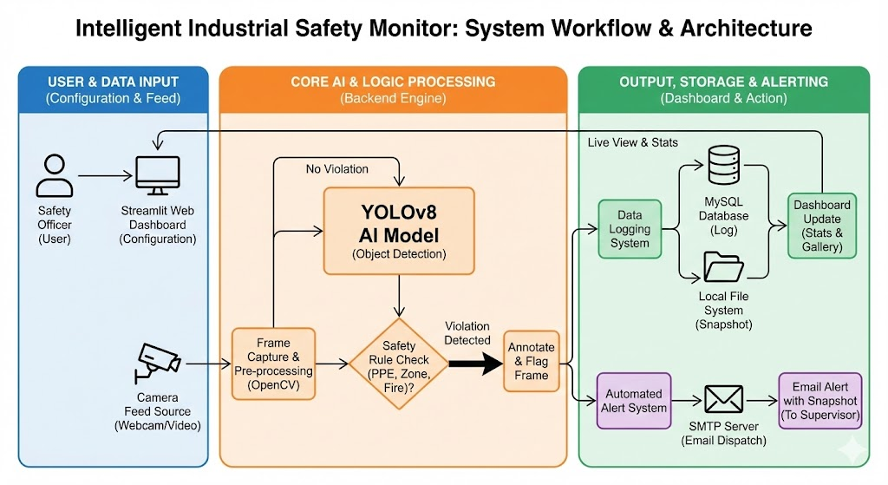

The application operates as a continuous, frame-by-frame processing loop divided into three core stages:
- Phase 1: Setup & Initialization
  - Bootstraps the OpenCV video feed and loads the pre-trained YOLOv26 weights into memory.
  - Enables interactive geofencing, allowing administrators to draw custom polygonal "Red Zones" directly onto the live camera feed.
- Phase 2: Inference & Detection
  - PPE Auditing: Evaluates personnel for missing safety gear (helmets/vests) and registers violations.
  - Boundary Monitoring: Calculates subject coordinates against the predefined "Red Zones" to detect unauthorized trespassing.
- Phase 3: Concurrent Alerting Mechanism
  - Visual Overlays: Renders immediate bounding boxes and warning labels on the local UI.
  - Evidence Logging: Captures and saves the localized frame with a timestamp.
  - Asynchronous Notifications: Triggers a background thread to email the captured violation snapshot to safety administrators without interrupting the live feed.

CONCLUSION

As of the current development cycle, the foundational analytical components of the "Intelligent Industrial Safety Monitor" have been successfully implemented. The primary objective during this evaluation phase was the architecture and deployment of a robust, low-latency computer vision pipeline capable of reliable hazard detection.

Key Milestones Achieved:

Dataset Curation and Model Optimization: A domain-specific dataset was compiled, encompassing construction-grade Personal Protective Equipment (helmets and high-visibility vests) alongside environmental anomaly indicators (fire and smoke). The YOLO object detection architecture was subsequently trained and fine-tuned to ensure high-throughput inference on standard, non-specialized hardware.

Continuous Ingestion Pipeline: A real-time video processing feed was established utilizing OpenCV, facilitating continuous, frame-by-frame data ingestion for live neural network evaluation.

Compliance Verification Logic: Algorithmic routines were developed to compute the spatial intersections between detected personnel and required safety gear, enabling the automated identification of safety protocol violations.

Geofencing and Spatial Intrusion Detection: A dynamic spatial monitoring module was engineered, allowing for the definition of custom polygonal boundaries (Red Zones). The system continuously maps the coordinate data of detected individuals against these perimeters, registering unauthorized access events in real time.

REMAINING WORK & FUTURE SCOPE

Upcoming Development Cycle: Alerting & Output Mechanisms Following the successful validation of the core inference engine, the project's subsequent development phase will pivot exclusively to the alerting and output architecture (Phase 3). The primary objective is to bridge the gap between backend algorithmic detections and actionable, real-time feedback for end-users and administrators.
Immediate Implementation Goals:
- Dynamic Visual Overlays: Implement real-time graphical annotations to superimpose bounding boxes and contextual warning labels (e.g., "PPE Violation: Helmet Missing" or "Restricted Area Breach") directly onto the live video stream, providing immediate on-screen feedback.
- Automated Audit Logging: Engineer a localized archiving module designed to isolate and extract the specific video frame of a confirmed infraction. This system will automatically log the event by saving a high-resolution, timestamped image artifact for evidentiary purposes.
- Asynchronous Alert Dispatch: Configure a background SMTP communication process to manage outgoing notifications. This dedicated thread will autonomously bundle the captured visual evidence with incident metadata, transmitting an immediate email alert to designated safety personnel without introducing latency into the primary video processing loop.

Future Scope:
This prototype establishes a foundation for enterprise-scale industrial applications. Future iterations could feature:
- Edge AI Deployment: Transitioning the model to hardware like the NVIDIA Jetson Nano for decentralized, on-site processing.
- Centralized Dashboarding: Building a full-stack Streamlit application for multi-camera management and real-time analytics.
- Cloud Integration: Connecting the logging system to cloud databases for long-term compliance tracking and historical data analysis.

REFERENCES

Books:
- Chollet, F. (2021). Deep Learning with Python (2nd ed.). Manning Publications.
- Bradski, G., & Kaehler, A. (2008). Learning OpenCV: Computer Vision with the OpenCV Library. O'Reilly Media.
Websites & Documentation:
- Python Software Foundation. (n.d.). Python 3.10 Documentation. Retrieved from https://docs.python.org/3/
- Ultralytics. (2023). YOLOv26 Documentation & GitHub Repository. Retrieved from https://docs.ultralytics.com/
- OpenCV Team. (2023). OpenCV (Open Source Computer Vision Library) Documentation. Retrieved from https://docs.opencv.org/
- Streamlit Inc. (2023). Streamlit Architecture and API Reference. Retrieved from https://docs.streamlit.io/
- PyTorch. (2023). PyTorch Core API Documentation. Retrieved from https://pytorch.org/docs/stable/index.html

